# How Auctions Are Raising Money for Coronavirus Relief

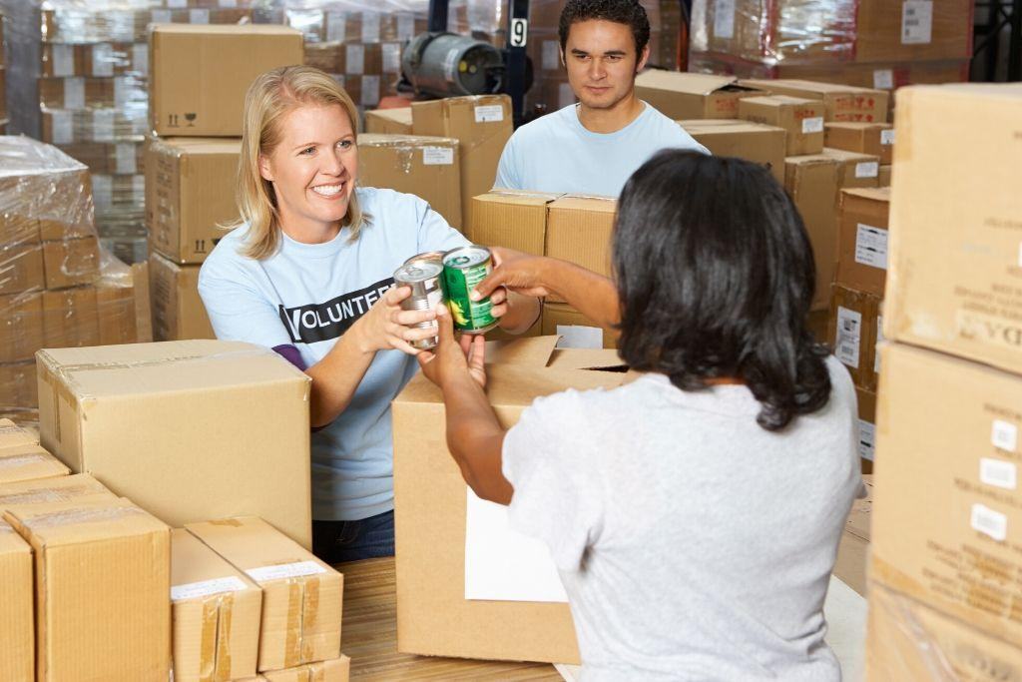

Within the last two months, our lives have been abruptly put on hold as we carefully navigate through the [coronavirus outbreak](https://www.dakil.com/auction-news/a-message-from-dakil-auctioneers-during-the-coronavirus-outbreak). By now, you’re likely accustomed to seeing the worst of these times, as businesses shutter and millions of Americans face financial hardships. But if there’s a silver lining or takeaway from this pandemic, it’s how our society can come together for a good cause — even in times of peril.

For hundreds of years, auctions have helped businesses and consumers intersect for a common cause — the sale of goods and services. Now, the [auction method](https://www.dakil.com/category/auction-101) is helping to raise millions of dollars for COVID-19 relief. We rounded up some of the most noteworthy examples of how selfless individuals and organizations are rallying around one another to benefit those in need.

## All-In Challenge

A viral challenge spread like wildfire earlier in April, as some of the world’s biggest stars teamed up to raise money that would help end food issues during the coronavirus.

Known as the [All-In Challenge](https://www.fanatics.com/all-in-challenge/x-12589906+z-9713580-3838082054), the fundraising auction started as a way for businessman Michael Rubin, who co-owns the NBA’s Philadelphia 76ers and is the chairperson of Fanatics, to connect athletes and celebrities with fans for a needed cause.

This is how it works: A star creates a short video explaining what they’re donating to the auction, ranging from batting lessons and an 18-hole round of golf to vacation packages and a [2021 Olympics experience](https://www.fanatics.com/olympic-games/experience-the-olympic-games-in-tokyo-courtesy-of-intel/t-21478210+p-6998008286364+z-9-934401862?_ref=p-CLP:m-GRID:i-r7c0:po-21). Then, at the end of the clip, they’ll challenge a friend or employer to put an item, event, or package together to auction off. The challenge also includes a sweepstakes where you can enter a drawing with entries of $10, $25, $50, and $100 to win once-in-a-lifetime experiences with famous musicians, television and movie stars, and celebrity chefs.

The All-In Challenge has raised more than $23 million with the proceeds helping organizations such as Meals on Wheels, Feeding America, and No Kid Hungry. Collectively, they’ll provide food to the millions of workers who are out of work and children who are out of school.

Some earlier auctions took in six figures, like [dinner and golf with Hall of Fame quarterback Peyton Manning](https://bleacherreport.com/articles/2889117-peyton-manning-golf-and-dinner-sells-for-525k-at-all-in-challenge-auction) that raised $525,000. For the winning bidder, Manning will fly to your hometown, play a round of golf at a local golf course, and take you and 10 friends to dinner to support a local restaurant.

### Other Celebrity Charity Auctions

A simple gift from fans sparked action from legendary musician Willie Nelson, who helped raise money to produce face masks for health care workers. A pair of fans in Texas sent Nelson masks for him and his wife. But, instead of keeping them, he decided to sign them and auction them off. The face masks have raised [more than $4,600 to date](https://www.charityauctionstoday.com/auctions/FrontLine-Angels-11490), which will help these Texans make more masks for health care workers.

## Businesses Using Auctions to Aid Employees

Employees are an integral part of any business, and one company recognized the importance of this through a benefit auction. Pinehurst Resort & Country Club in North Carolina, home to many prestigious major golf tournaments, [auctioned off fan experiences](https://www.pinehurst.com/news/auction-of-once-in-a-lifetime-experiences-raises-almost-300000-for-pinehurst-resort-employees/) in March to help the hundreds of employees who were out of work due to the coronavirus. The packages included private walking tours, rounds of golf, and vacation stays on the property to help raise more than $294,000.

For years, comic collections have been popular items at estate sales and auctions. Now, a group of comic creators banded together to help comic shops, independent bookstores, and their employees across the country navigate through this pandemic. To date, [Creators 4 Comics](https://www.creators4comics.com/) has raised more than $430,000 through comics, art, novels, and fan experiences. The proceeds go to the Book Industry Charitable Foundation, a non-profit organization that provides emergency financial help to small business owners and employees in need.

In Boston, an entertainment company turned to a combination of [auctions and social media](https://www.instagram.com/bignightent/) to assist their employees. Big Night Entertainment Group has raised several hundred thousand dollars to help hundreds of employees in need. Each day, BNEG posts an auction item on Instagram featuring concert tickets, sporting events, and celebrity meet and greets.

## NFL Draft-A-Thon

Millions of NFL fans eagerly tune into the NFL Draft each spring as a way to gather excitement for the upcoming season. This year’s draft detoured from the usual in-person celebration to a virtual draft in the wake of the coronavirus pandemic. To coincide with the online draft, the NFL created a virtual NFL Draft-A-Thon [where current and former NFL players teamed up with movie stars,](https://nflauction.nfl.com/iSynApp/showPage.action?sid=1100783&pageName=partners&pgmode1=disasterRelief&pgmode2=partner&pgmode3=curbid_desc&rc=10&rs=0) musicians, and other celebrities to raise money for charities.

Most of the items up for auction feature autographed worn jerseys, helmets, or game balls that range from a few hundred dollars to several thousand dollars. The most money raised to date comes from a fan experience that allows you to watch a [Monday Night Football game with NFL Commissioner Roger Goodell](https://nflauction.nfl.com/iSynApp/auctionDisplay.action?auctionId=3136325) in his fan cave (basement). The package, which also includes two tickets to any NFL game in 2020, has raised more than $200,000.

The auction proceeds will go to the American Red Cross, CDC Foundation's All of Us, Feeding America's COVID-19 Response Fund for member food banks, Meals on Wheels COVID-19 Response Fund, the Salvation Army, and United Way's COVID-19 Community Response and Recovery Fund.

## Rare Car Auctions

Do you have an appreciation for cars? Then you’ll find this next nugget interesting. [Porsche auctioned off its final 991 Generation Porsche 911 speedster](https://www.caranddriver.com/news/a32112550/final-991-porsche-911-auction-coronavirus-charity/), a two-door convertible with a six-speed manual transmission that retails for more than $275,000.

The high-end racer sold for $500,000, and Porsche matched the amount to donate a total of $1 million to the United Way Worldwide coronavirus relief fund. The winning bid also received a watch and a tour of Porsche’s development facility. Porsche first debuted its seventh generation model in 2011 and assembled this final car in December 2019.

For those who are more into stock car racing, NASCAR team owner Richard Childress is [auctioning off Dale Earnhardt’s No. 3 car](https://www.charlotteobserver.com/sports/nascar-auto-racing/thatsracin/article242264111.html). Earnhardt, a fan favorite and one of the sport’s best drivers, died in a 2001 crash at the Daytona 500. The winning proceeds will help first responders, health care workers, and local food banks.

## Putting Movie Props to Good Use

An independent production company is [auctioning off set items](https://nypost.com/2020/04/22/a24-auctions-off-props-from-midsommar-uncut-gems-for-coronavirus-relief/) from some of its more recent popular movies. Props and costumes from hits such as “Uncut Gems,” “Mid90s,” and “Midsommar” will help raise money for local charities and hospitals.

The auction, started by A24, lists items such as a light-up race car bed, a bat mitzvah dress, and a Boston Celtics jersey from the crime thriller “Uncut Gems,” which features Adam Sandler and former NBA player Kevin Garnett.

## Stay in Touch With Us

You can contact our office at 405-751-6179 for more information on our [**upcoming auctions**](https://www.dakil.com/upcoming-auctions) when they resume in mid-May. You can also [**subscribe to our newsletter**](https://www.dakil.com/subscribe-to-dakils-newsletter) to see the latest trends in the auction industry.

In the meantime, stay up to date on the coronavirus and COVID-19 outbreak via resources from the [**Centers for Disease Control and Prevention**](https://www.cdc.gov/coronavirus/2019-ncov/index.html) and the [**World Health Organization**](https://www.cdc.gov/coronavirus/2019-ncov/index.html). For Oklahoma residents, the [**Oklahoma State Health Department’s**](https://coronavirus.health.ok.gov/) resource center provides statewide news and updates. You can also check out the [**OKC-County Health Department coronavirus page**](https://www.occhd.org/COVID-19) for any Oklahoma City mandates, business closures, and updates.